Project Charter
Date 03/29/2022

Project Title: PHANST-Event Management Services
Project Start Date: 01-26-2022 Projected Finish Date: 04-30-2022
Budget Information: The project would cost around 15,000 $ for completion.
Project Manager: Navya Sri Alaparthi, S545610@nwmissouri.edu
Project Objectives:
To help the people provide an online portal for organizing events in this pandemic like marriages, birthday parties, house warming and many more events

Success Criteria:
- Client needs must be met.
- Project must stick to the deadlines.
- Project should be finished on time and on budget.
- Before the deadline, our website should be up and running with no mistakes.
- Project should also meet all the requirements outlined in the scope.

Approach:
We would use an agile strategy for this project. The needs of the client will be gathered, and appropriate action will be taken. As a collective, we will not fail anyone or anything in this effort. Everyone on the team is willing to lend a hand to the others. Because we have other members to mask our shortcomings, we can keep our flaws hidden. We'll conduct daily Zoom meetings to keep track of the project's progress and help each other out if someone falls behind. We'll use Northwest Email and Microsoft Teams for Business to hold quick online meetings.
Roles and Responsibilities
Name and Signature | Role | Position | Contact Information
Navya Sri Alaparthi  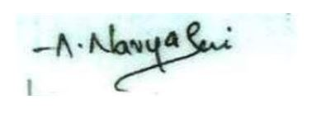 | Project Manager | Project manager/ Web developer | S545610@nwmissouri.edu
Sravani Kodipelly  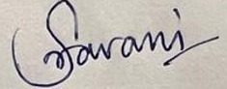 | Project Lead | Team Lead/ User Interface Developer | S544914@ nwmissouri.edu
Harshita Dandyala  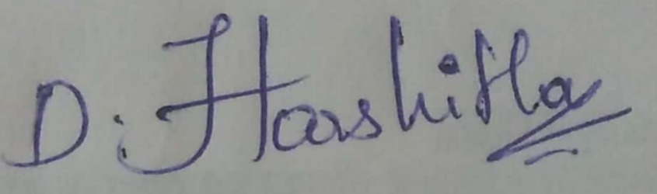 | Team Member | Full Stack Developer | S545413@ nwmissouri.edu
Anusha Bandari  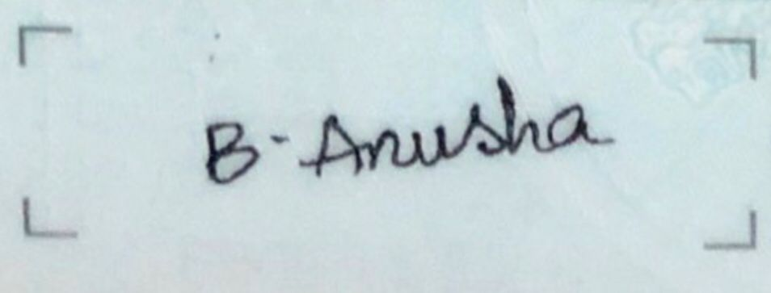 | Team Member | Backend Developer | S545148@ nwmissouri.edu
Pravallika Maddelaveda  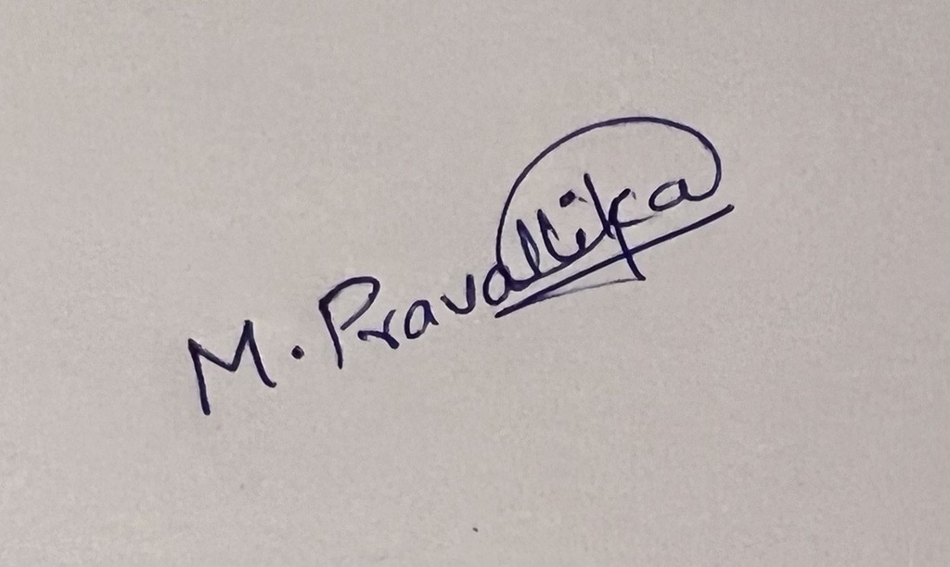 | Team Member | Quality Analyst | S545254@ nwmissouri.edu
Tejaswi Gannamaneni  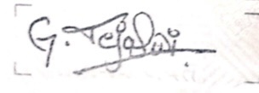 | Team Member | Business Analyst | S545396@ nwmissouri.edu
Comments: (Handwritten or typed comments from above stakeholders, if applicable)

LOGO

